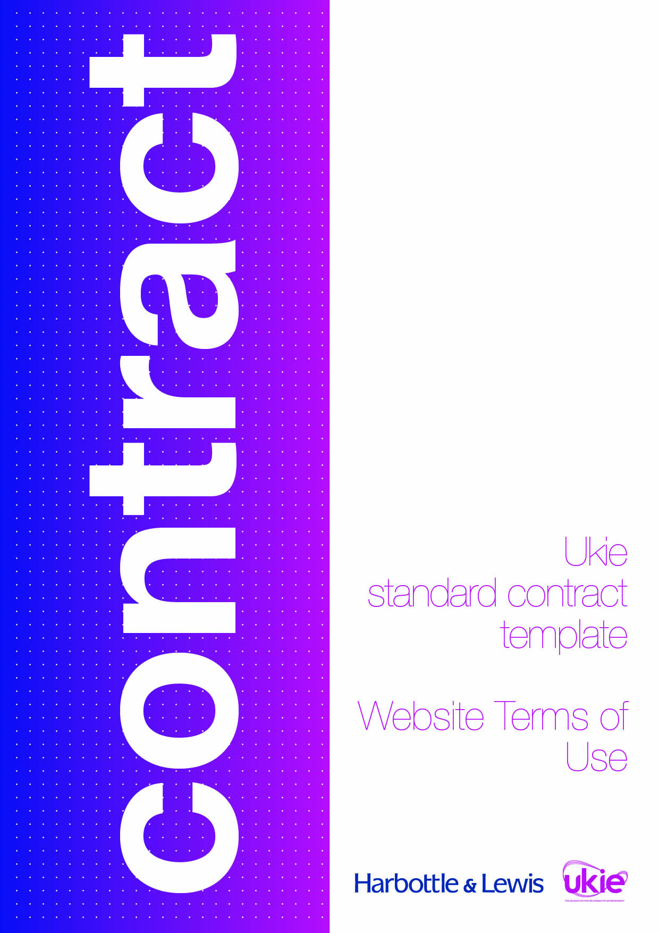
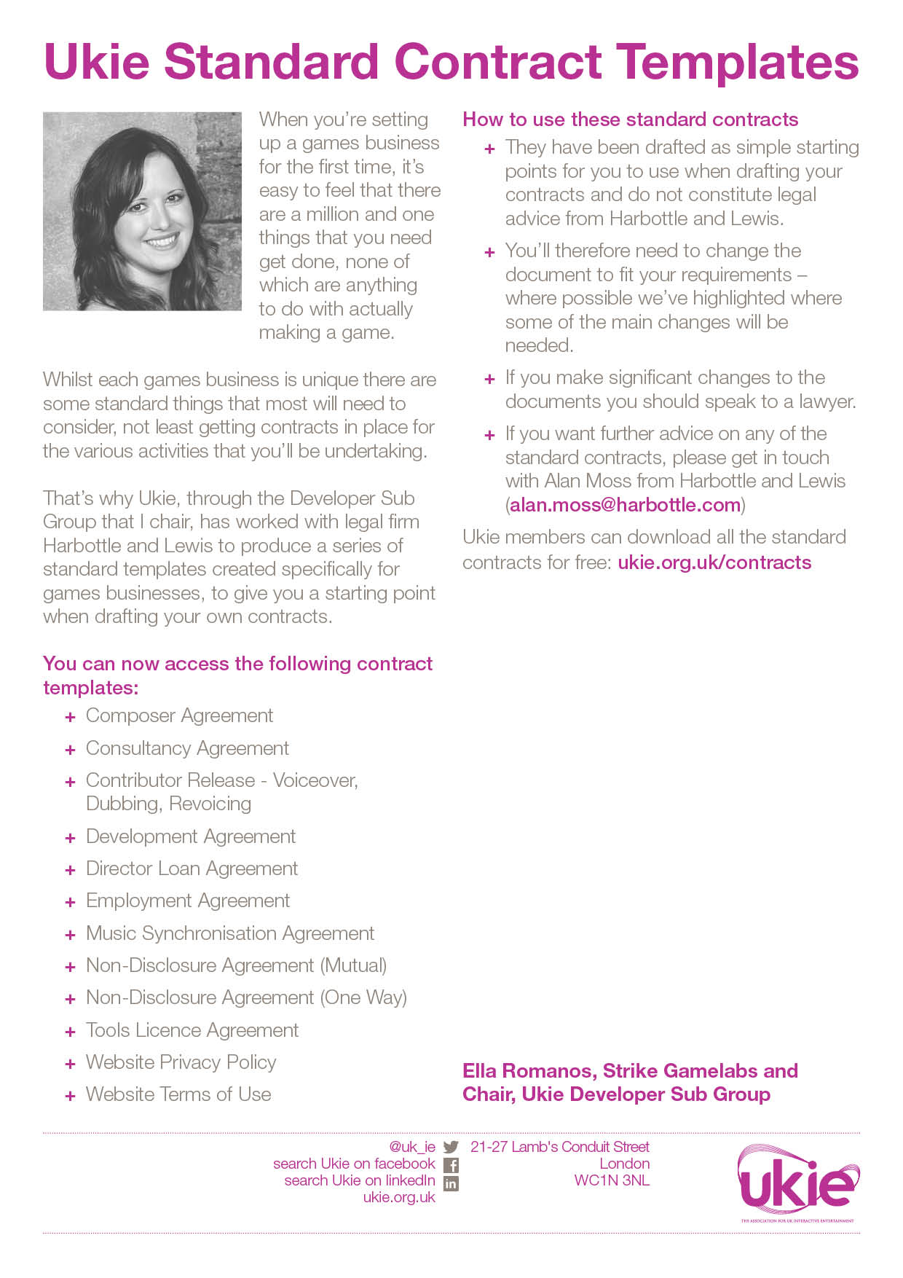

UKIE CONTRACT TEMPLATE
WEBSITE TERMS OF USE
IMPORTANT NOTES – PLEASE READ BEFORE USING THIS DOCUMENT
- This document has been prepared by Ukie Associate Member, Harbottle & Lewis. It is a basic set of website terms and conditions intended to be used as a starting-point by the operator of a simple website.
- This document contains various placeholders in yellow highlighted square brackets which will need to be completed before it can be used.
- This document assumes:
  - the website in question is primarily used to advertise the activities of a games developer;
  - the website in question is not being used as an e-commerce platform through which goods and services can be purchased; and
  - the website may have a basic mechanism for users to post user generated content to the website but does not have a mechanism for users to create accounts on the website and is not a social media platform.
- This template is not suitable for a website that is used to sell any goods or services directly through the website. There are a number of additional legal requirements that apply to the operator of an e-commerce website and you should seek legal advice if you require terms and conditions for an e-commerce website.
- This document has been prepared in light of the applicable English law as at June 2016 and will not reflect any subsequent changes to the law after such date.
- This document is intended to be used as a simple starting-point for a first draft of the document and does not constitute legal advice from Harbottle & Lewis LLP. You should seek legal advice if you intend to make any changes to the document. Please contact Daniel Tozer (daniel.tozer@harbottle.com) if you wish to discuss any aspect of the document.
Website Terms of Use

Introduction

These terms of use (Terms) set out the basis on which you may browse and use our website, available at [INSERT URL ADDRESS] (Site) and any services, content and materials offered through it.

This Site is owned and operated by [INSERT FULL COMPANY NAME], with registered no. [INSERT COMPANY NUMBER] and registered address at [INSERT ADDRESS] (we, us or our). Our VAT number is [INSERT VAT NUMBER].

Your use of this Site will be governed by these Terms which will be a legal contract between us and you. By browsing or using this Site and/or any of the services, content or materials made available through this Site you are agreeing to be legally bound by these Terms.

If you would like to contact us for any reason please do so using the following details:
Address: | [INSERT CONTACT ADDRESS]
Email: | [INSERT CONTACT EMAIL]
Tel: | [INSERT CONTACT TELEPHONE NUMBER]

Changes to these Terms

We may revise these Terms at any time by amending this page. Your use of this Site will be subject to the most recent version of these Terms available on this Site.

We recommend that you regularly read through the latest version of these Terms that is available on this Site so that you can be sure that you are aware of any changes that may apply to you.

Access and use of this Site

This Site and the services, content and materials made available through it are currently made available to you free of charge. We reserve the right to charge for access to the Site or any of the services, content or materials made available through it in future. If we decide to charge for access to this Site or any of the services, content or materials available through it, we will try to give you reasonable notice of any such charges before implementing them.

Access to this Site and the services, content and materials made available through it is permitted on a temporary basis. We may suspend, withdraw, discontinue or change all or any part of the Site without notice to you.

You must not misuse the Site by knowingly introducing viruses, trojans, worms, logic bombs, bots, keyloggers, rootkits, spyware, malware or any other material which is malicious, has a deleterious effect, is technologically harmful or is otherwise designed to provide you or any third party with unauthorised access to this Site, our servers or any other third party’s server, device or information. You must not attempt to gain unauthorised access to this Site, the server on which this Site is stored or any server, device or information. You must not attack the Site via a denial-of-service attack or a distributed denial-of service attack. By breaching this provision, you would commit a criminal offence under the Computer Misuse Act 1990. We will report any such breach to the relevant law enforcement authorities and we will co-operate with those authorities by disclosing your identity to them. In the event of such a breach, your right to use the Site and the services, content and materials made available through it will cease immediately.

You are responsible for making all arrangements necessary for you to have access to this Site.

Uploading content to this Site

From time to time this Site may include functionality that enables you to upload content directly on to this Site, such as blogs or message boards which allow the upload of user generated content (UGC Functionality).

When using any UGC Functionality on this Site, you agree that you will not submit or upload any content:

that is confidential, defamatory, infringing, pornographic, obscene, offensive, racist, indecent, threatening, harassing or otherwise unlawful or objectionable;

that you do not own or do not have the permission of the owner or any other relevant person who may have rights in or connected to the content you are uploading;

that includes any personal data if uploading it to the Site would be a breach of the Data Protection Act 1998, infringe any third party’s rights of privacy or publicity or breach any other applicable data protection or privacy legislation; or

if submitting it to this Site would infringe the intellectual property rights or any other rights of another person.

As between you and us, you will own any content or material you upload to the Site (Your Content). You agree that we shall have the perpetual, royalty-free and worldwide right to copy, store, distribute, adapt, communicate it to the public, publicly perform, and use Your Content for any purpose in connection with the operation or exploitation of this Site or any of the services, content or materials made available through it.

The views expressed by other users on this Site do not represent our views or values. We will not be responsible, or liable to you or any third party, for any content posted by you or any other user of this Site.

We also have the right to disclose your identity to any third party who is claiming that any content posted or uploaded by you to this Site constitutes a violation of their intellectual property rights, right to privacy or publicity, is defamatory of them, or otherwise infringes any of their other legal rights.

Notice and takedown procedure

We do not actively monitor the content that users of this Site upload onto this Site. We do not therefore accept any responsibility or liability for any such content on this Site.

If you become aware that any other member of this Site has posted content which is inaccurate, inappropriate, offensive or does not comply with any of the provisions of these Terms (Disputed Content), you may notify us by contacting us at: [INSERT EMAIL ADDRESS] and providing us with adequate details of the Disputed Content in question and where it is located on this Site. We will act promptly in dealing with the Disputed Content in question following our receipt of your notice.

We have the right to remove Your Content at any time for any reason and without notice in our sole discretion.

For the avoidance of doubt, any decision we make in connection with the removal or disablement of any content from this Site is final and we accept no liability to you in respect of any such decision.

Intellectual property rights

We are the owner or the licensee of all intellectual property rights in this Site and in any services, content and materials that are made available through it.

You may print off, and copy extracts of, any of the content or materials made available through this Site, for any non-commercial or personal use or as otherwise expressly permitted by any copyright exceptions that are available to you under applicable law. Unless you have the right to do so pursuant to any copyright exceptions available to you under applicable law, you acknowledge and agree that you will not:

reproduce or include any such content or material in any other commercial work or publication in any medium;

modify or alter any such content or material in any way;

distribute or sell (or make any offer to distribute or sell) any such content or material to any third party; or

remove any copyright, trademark or other proprietary notices contained in any such content or material.

You must not use any of the services, content or materials made available through this Site for any commercial purpose without first obtaining a licence to do so from us or our licensors.

If you copy or use any part of this Site or any of the services, content or materials made available through it in breach of these Terms, your right to use this Site will cease immediately and you must, at our option, return or destroy any copies that you have made of this Site or any of the services, content or materials made available through it.

Data protection and privacy

Any personal information that we collect from you as you browse and use this Site will be used in accordance with our privacy policy. To find out more about the data we collect from you and how we use it please read our privacy policy available here: [INSERT LINK].

By accepting these Terms, you also consent to our use of your personal data in accordance with our privacy policy.

Links to and from this Site

You may link to any page of this Site that is not behind a paywall, provided that you do so in a way that is fair and legal and does not damage our reputation or take advantage of it. You must not establish a link in such a way as to suggest any form of association, approval or endorsement on our part where none exists.

We reserve the right to withdraw linking permission without notice. If you wish to link to any page of this Site that is behind a paywall, you may only do so with our prior written consent. We reserve the right to grant or withhold such consent in our absolute discretion.

Where this Site contains links to other websites and resources provided by third parties, these links are provided for your information only. We have no control over the content of those websites or resources and we are not responsible or liable for them in anyway.

Disclaimers

We will endeavour to use reasonable care and skill in making this Site available to you.

Except as expressly provided in these Terms, this Site and any services, content and materials made available through it are provided on an "as is" basis. We do not make any representation or warranty of any kind, either express or implied (whether by common law, custom, statute or otherwise) in relation to this Site or any services, content or materials made available through it including, without limitation, any warranties in relation to fitness for a particular purpose or in relation to quality, completeness, accuracy, reliability or non-infringement.

The information available on this Site is not intended to amount to advice on which you should rely. You should obtain professional or specialist advice before taking, or refraining from, any action on the basis of any of the information available on this Site. Although we make reasonable efforts to update the information available on this Site, we make no representations, warranties or guarantees, whether express or implied, that such information is accurate, complete or up-to-date.

We do not guarantee that this Site will always be available, be uninterrupted, secure or free from bugs or viruses, nor that this Site or any products, services or content provided through it will be free from errors or omissions. As we cannot guarantee that this Site will be free from bugs or viruses, we recommend that you use anti-virus software to protect your device when accessing this Site.

Limitation of our liability

Nothing in the Terms excludes or limits our liability for death or personal injury arising from our negligence, for fraud or fraudulent misrepresentation, or any other liability that cannot be excluded, disclaimed or limited by applicable law.

To the extent permitted by law, we exclude all conditions, warranties, representations or other terms that may apply to this Site or any of the services, content or materials available through it, whether express or implied.

We will not be liable to you or any other user of this Site for any indirect, special or punitive loss or damage, whether in contract, tort (including negligence), breach of statutory duty, or otherwise, arising under or in connection with the use of, or inability to use, this Site or any of the services, content or materials available through it. In addition, we will not be liable to you or any other user of this Site for any direct loss of profit, data, reputation or goodwill, opportunity or anticipated savings.

General

These Terms do not create or infer any rights that are enforceable by any person who is not a party to them.

You may not assign, sub-license or otherwise transfer any of your rights or obligations under these Terms to any other person without our prior written consent.

If we decide not to exercise or enforce any right that we have against you at a particular time, then this does not prevent us from later deciding to exercise or enforce that right.

If any part of these Terms is found to be illegal, invalid or otherwise unenforceable by a court or regulator, then, where required, that part shall be deleted from these Terms and the remaining parts of these Terms will continue to be enforceable.

These Terms and any dispute arising out of or in connection with them (including any non-contractual claims) shall be governed by and construed in accordance with English law and you agree to submit to the non-exclusive jurisdiction of the English courts.

