

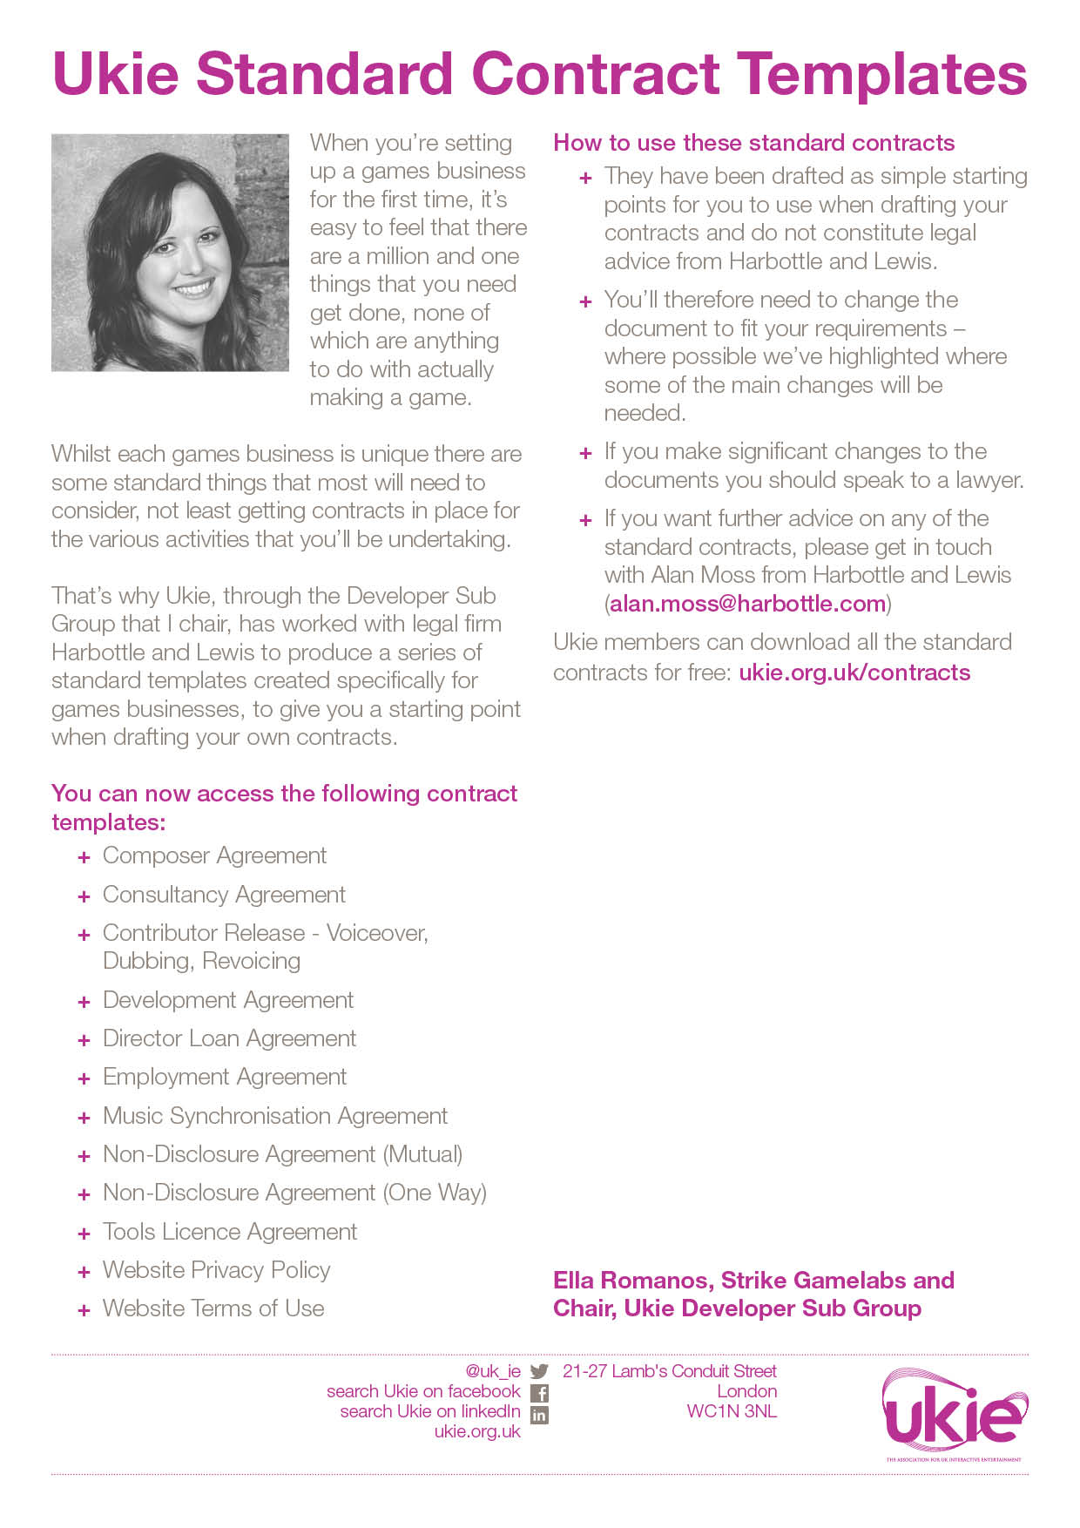

UKIE CONTRACT TEMPLATE
DIRECTOR’S LOAN AGREEMENT
IMPORTANT NOTES – PLEASE READ BEFORE USING THIS DOCUMENT
- This document has been prepared by Ukie Associate Member, Harbottle & Lewis. It is a basic form of a loan agreement to formalise a simple non-interest bearing loan between a director of a company and the company.
- This document contains various placeholders in yellow highlighted square brackets that will need to be reviewed and either completed, deleted, accepted or amended before it can be used.
- This document is only suitable where the director is the majority or sole shareholder of the company. It is not suitable for debt arrangements between the company and third parties (such as banks, institutional lenders or investors).
- This document has been prepared in light of the applicable English law as at June 2016 and will not reflect any subsequent changes to the law after such date.
- This document is intended to be used as a simple starting-point for a first draft of the document and does not constitute legal advice from Harbottle & Lewis LLP. You should seek legal advice if you intend to make any changes to the document. Please contact Charles Leveque (charles.leveque@harbottle.com) if you wish to discuss any aspect of the document.

From: [INSERT NAME OF DIRECTOR]
[INSERT ADDRESS OF DIRECTOR]

To: [INSERT NAME OF COMPANY]
[INSERT ADDRESS OF COMPANY]
(Company)
[INSERT DATE]
Dear Sirs
Loan agreement
I am writing to confirm the terms under which I have agreed to make available a loan to Company (Loan).

Amount
The Loan is for an amount of £[INSERT LOAN AMOUNT].

Availability
The Loan shall be available for draw down immediately from the date of this letter.

Interest and Security
The Loan shall be non-interest bearing and unsecured.

Repayment

Unless otherwise agreed in writing between Company and me, the Loan shall be immediately repayable in full on the earlier of:

[INSERT DATE OF REPAYMENT]; and

the date of an Event of Default.

An Event of Default means the occurrence of any of the following events:

an application is made or any other steps are taken for:

the appointment to Company of an administrator or similar officer to manage its affairs, business, property undertaking and/or assets or documents are filed with a court of competent jurisdiction for the appointment of an administrator to Company or notice of intention to appoint an administrator in respect of Company given by Company, its directors or any qualifying floating charge holder (as defined in paragraph 14, Schedule B1 Insolvency Act 1986) or an administration order is made in respect of Company; or

the winding up or dissolution of Company or the appointment to Company of a liquidator, trustee, receiver or similar officer; or

Company makes a proposal for the entering into of a compromise with the majority by value of its unsecured creditors or files the documents specified in Schedule A1 of the Insolvency Act 1986 with the court with a view to obtaining a moratorium pursuant to the provisions of that Schedule.

Any amounts repaid may not be re-borrowed without my prior written consent.

Counterparts

This letter may be executed in any number of counterparts, each of which, when executed and delivered shall constitute a duplicate original, but all the counterparts shall together constitute the one agreement.

Entire Agreement

This letter constitutes the entire agreement between us and supersedes any previous agreement or understanding between us relating to this subject matter.

Third Parties

The Contracts (Rights of Third Parties) Act 1999 shall not apply to this letter and no person other than the parties to this letter shall have any rights under it.

Governing Law and Jurisdiction
This letter and any dispute or claim arising out of or in connection with this letter or its subject matter (including non-contractual disputes or claims) shall be governed by and construed in accordance with English law and the parties to this letter hereby submit to the exclusive jurisdiction of the English courts.
Yours faithfully

……………………………………………….
[INSERT NAME OF DIRECTOR]

Agreed and acknowledged by Company

……………………………………………….
For and on behalf of [INSERT NAME OF COMPANY]

