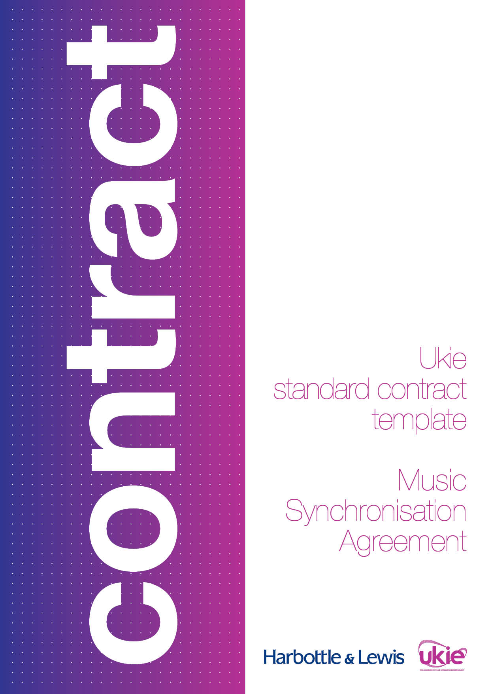

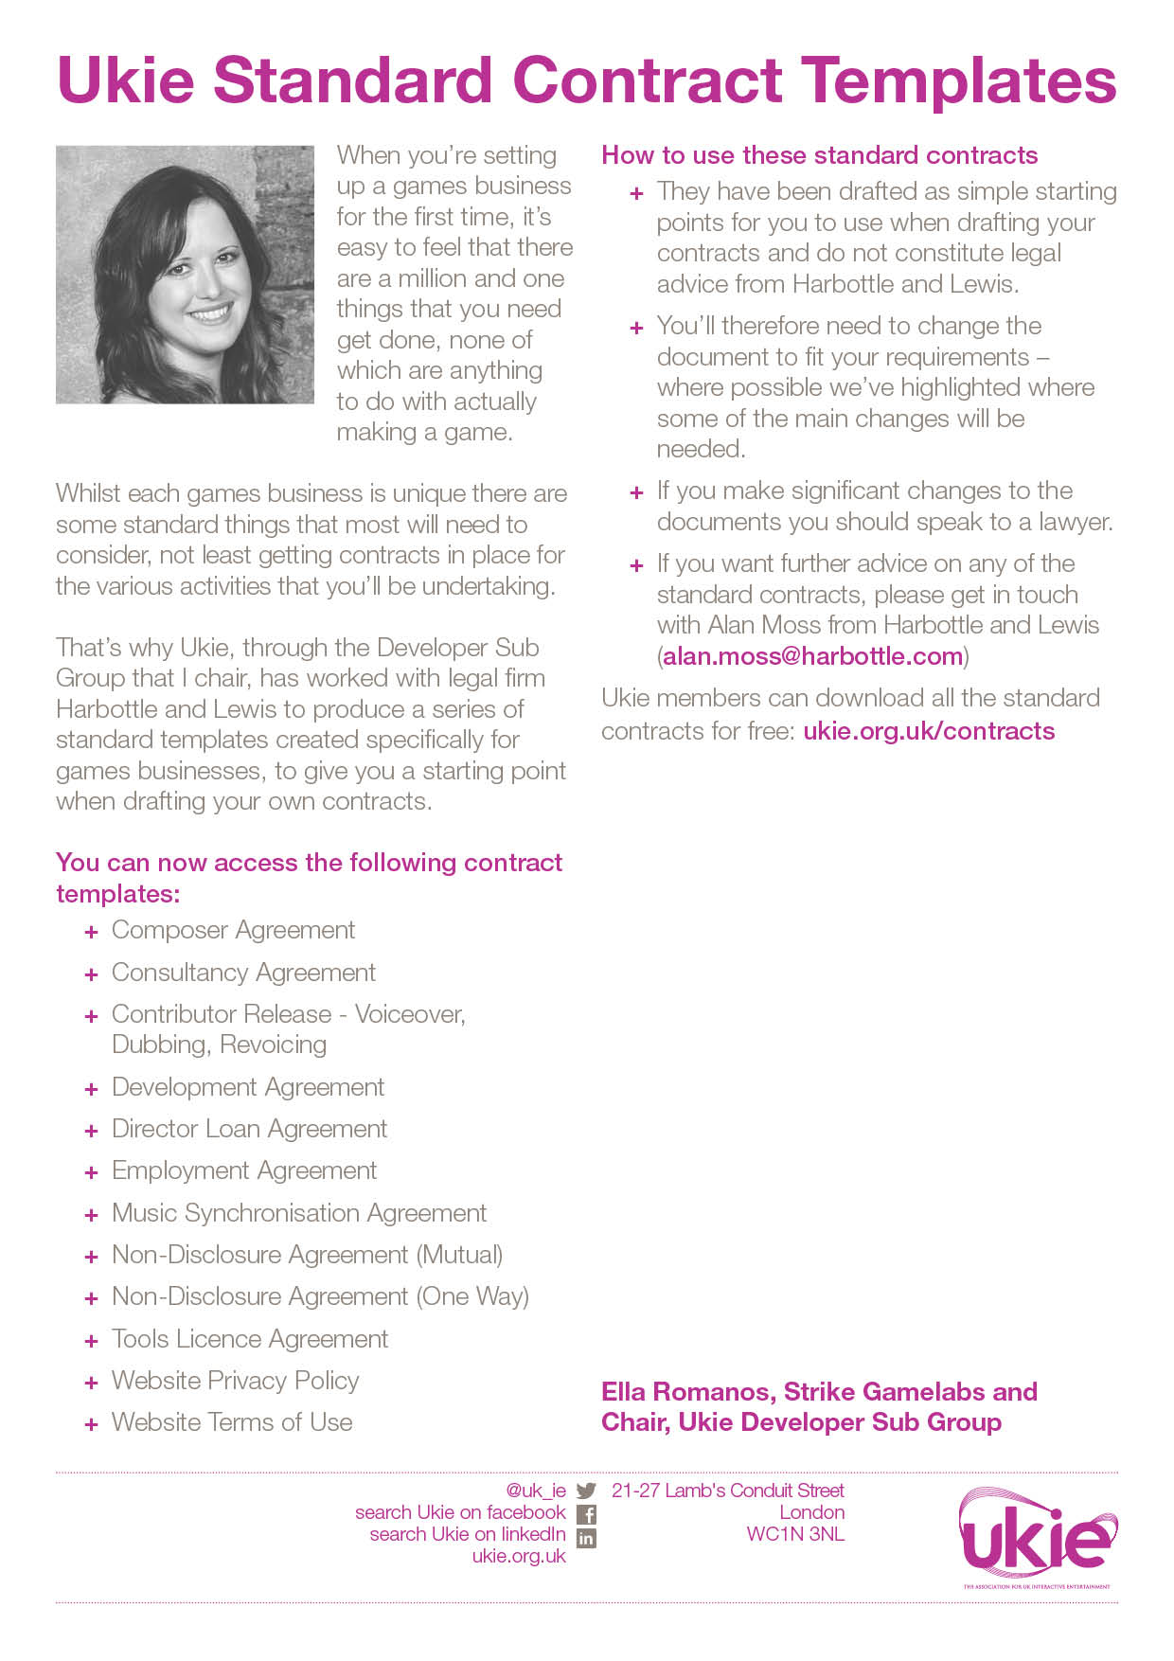

UKIE CONTRACT TEMPLATE
MUSIC SYNCHRONISATION AGREEMENT
IMPORTANT NOTES – PLEASE READ BEFORE USING THIS DOCUMENT
- This document has been prepared by Ukie Associate Member, Harbottle & Lewis. It is a basic music synchronisation agreement intended to be used as a starting-point by a party wishing to obtain a licence from another party to use certain music in a video game.
- This document assumes that the relationship between the parties will be an arm’s length arrangement whereby the party obtaining the licence will:
  - pay the other party a flat fee in exchange for the right to use the music in its video game; and
  - have no obligation to pay the other party any on-going royalty.
- This document is designed to be fair and balanced and not to place unreasonable obligations on either party. If further protections for either party or a more tailored approach is required, you should seek legal advice.
- This document contains various placeholders in yellow highlighted square brackets that will need to be reviewed and either completed, deleted, accepted or amended before it can be issued.
- This document has been prepared in light of the applicable English law as at April 2016 and will not reflect any subsequent changes to the law after such date.
- This document is intended to be used as a simple starting-point for a first draft of the document and does not constitute legal advice from Harbottle & Lewis LLP. You should seek legal advice if you intend to make any changes to the document. Please contact Chloe Forsyth (chloe.forsyth@harbottle.com) if you wish to discuss any aspect of this document.

Dated 20[]
Music Synchronisation Agreement

- [INSERT NAME OF DEVELOPER]
- [INSERT NAME OF LICENSOR]

MUSIC SYNCHRONISATION AGREEMENT
THIS MUSIC SYNCHRONISATION AGREEMENT is dated [INSERT DATE].
PARTIES:
- [INSERT DEVELOPER’S NAME] a company incorporated under the laws of England and Wales (Company number [INSERT NUMBER]) and having its registered office at [INSERT ADDRESS] (Developer); and
- [INSERT LICENSOR’S NAME] a company incorporated under the laws of England and Wales (Company number [INSERT NUMBER]) and having its registered office at [INSERT ADDRESS] (Licensor).
WHEREAS:
- Developer wishes to use certain musical works (including any lyrics where applicable) (Music) and sound recordings (Recordings) that are owned and controlled by Licensor in a video game provisionally entitled “[INSERT TITLE]” (Game) which Developer intends, but does not undertake, to produce, as more particularly set out in the Schedule hereto.
- The Developer and Licensor have agreed to contract for the said purposes in accordance with the terms and conditions set out in this Music Synchronisation Agreement (Agreement).
NOW IT IS AGREED as follows:
- Grant of Rights
    - In consideration for the payment to Licensor of £[INSERT AMOUNT] (Fee) receipt and sufficiency of which Licensor hereby acknowledges, Licensor grants to the Developer and its successors in title with full title guarantee:
      - a non-exclusive, perpetual, irrevocable, worldwide, sub-licensable and royalty-free licence to store, perform, reproduce, transmit, communicate to the public, publicly perform and use all or part of the Music and Recordings in synchronisation with the Game (including, without limitation, any trailers, prequels, sequels, ports, cut-downs, alternative edits, adaptations and versions of the Game plus in any “making of the Game” film and bonus Game material (including any “DLC”), variations in language and sub-titling where necessary, and for ancillary promotions, marketing, and publicity relating to the Game) and to exploit the Game in such manner and through any and all media now existing or invented, developed or made available in the future as Developer shall in its absolute discretion decide and on a so-called “buy-out” basis without payment of any so-called mechanical licence payments (including for the avoidance of any doubt any mechanical royalties); and
      - any and all rental and lending rights and cable and satellite retransmission rights in relation to the licence of the Recordings and the Music and Licensor confirms that the Fee includes: (a) adequate and equitable remuneration in respect of the licence of the said rental and lending right; and (b) all royalties or other payments which are due to any individual producer, mixer or remixer of the Recordings or any other person, firm or corporation to whom a royalty or other premium is payable, and all payments due in respect of the Recordings under the agreements and rules of the American Federation of Musicians, AFTRA, or any relevant trust funds or any similar unions.
    - Licensor hereby gives all consents required by the Copyright, Designs and Patents Act 1988 (Act) to allow the fullest possible exploitation of the Recordings and the Music as contemplated by this Agreement.
    - Licensor hereby irrevocably waives any so-called moral rights in respect of the Music and the Recordings to which Licensor may be entitled including, without limitation, any rights under Sections 77 and 80 of the Act or any similar laws of any jurisdiction and Licensor agrees not to bring any action against the Developer its licensees or assigns alleging any breach of any such rights.

Nothing in this Agreement shall prevent Licensor and, if applicable, the composer of the Music from being entitled to receive any and all public performance income from the Music under collecting and other agreements negotiated by recognised collecting societies under the laws of any jurisdiction or otherwise pursuant to government regulations provided that it is acknowledged that Developer itself shall not be obliged to make any such payments to Licensor, the composer of the Music (if applicable) and/or such collecting societies.
  - Credit
Developer shall use its reasonable endeavours to afford Licensor the following credit in the credits section of the Game:
“Music by [INSERT NAME].”
  - Representations, Warranties and Undertakings
    - Each of the parties warrants and undertakes to the other party that:
      - it is a validly formed company in good standing; and
      - it has the right and full power and authority to: (a) enter into this Agreement; and (b) perform its obligations in accordance with the terms of this Agreement.
    - Licensor hereby represents, warrants and undertakes that:
      - Licensor is the unencumbered owner of the entire copyright in both the Music and the Recordings and nothing contained in the Music or in the Recordings infringes the copyright or any other rights of any third party;
      - Licensor is vested with all rights necessary to enable it to grant the rights and licences it is granting to Developer under this Agreement;
      - Licensor has obtained all consents in connection with the musicians’ performances (if any) contained in the Recordings necessary to enable the Recordings to be exploited in accordance with the terms of this Agreement;
      - no claims shall be made against the Developer by Licensor or any person, firm or corporation (or other legal entity) deriving title from Licensor in respect of the use of the Music and Recordings in or in relation to the Game; and
      - Licensor will execute and deliver at the sole expense of the Developer any documents required for the purpose of confirming or further assuring the terms of this Agreement.
  - Indemnity and Default
    - Licensor hereby indemnifies Developer, and shall keep Developer indemnified, from and against all claims, demands, actions, proceedings, costs, damages, losses and expenses (including, but not limited to, any and all legal costs and expenses and VAT) whether suffered or incurred directly or indirectly by Developer or any compensation paid or agreed to be paid by Developer to any third party or arising out of any breach, non-performance or non-observance of any of the covenants, warranties, representations, undertakings and agreements of the Composer contained or implied in this Agreement.
    - Licensor agrees that, in the event of any default of any of the terms of this Agreement by Developer, Licensor’s only remedy shall be an action at law for damages, if any, actually or directly suffered by Licensor. In no event shall Licensor be entitled to rescind this Agreement, receive injunctive or other equitable relief or enjoin or restrain the distribution, exhibition, advertising or other exploitation of any materials which the Developer produces, or intends to produce, in furtherance of the rights granted to it hereunder in any jurisdiction throughout the world.
  - Miscellaneous
    - Developer shall be entitled to assign or license to any third party or authorise or permit any third party to exercise any or all of the rights of Developer hereunder in the Music and/or Recordings.
    - If any term of this Agreement is found to be illegal, invalid or unenforceable under any applicable law, such term shall, insofar as it is severable from the remaining terms, be deemed omitted from this Agreement and shall in no way affect the legality, validity or enforceability of the remaining terms provided that if any provision of this Agreement is so found to be invalid or unenforceable but would be valid or enforceable if some part of the provision were deleted, the provision in question shall be amended as may be necessary to make it valid.
    - This Agreement sets out the entire agreement and supersedes any previous agreement or understanding, whether written or oral, between the parties relating to its subject matter.
    - This Agreement is binding upon the representatives, executors, administrators and assigns of the parties hereto. The Schedule to this Agreement forms part of this Agreement.
    - The Contracts (Rights of Third Parties) Act 1999 shall not apply to this Agreement and no person that is not a party to this Agreement shall have any rights under it. This Agreement may be varied, amended, modified, suspended, rescinded or terminated in each case without the consent of any third party.
    - This Agreement may be executed in any number of counterparts, each of which, when executed and delivered shall constitute a duplicate original, but all the counterparts shall together constitute the one agreement.
    - This Agreement and any dispute or claim arising out of or in connection with this Agreement or its subject matter (including non-contractual disputes or claims) shall be governed by and construed in accordance with English law and the parties hereby submit to the exclusive jurisdiction of the English courts.
IN WITNESS of which this Agreement has been entered into on the date stated at the beginning of it.
signed for and on behalf of  [INSERT NAME OF DEVELOPER]:  ……………………………………………..……………  Director | signed for and on behalf of  [INSERT NAME OF LICENSOR]:  ……………………………………………..……………  Director

SCHEDULE
Music: | “[]” written and composed by [INSERT NAME]
Recordings: | “[]” performed by [INSERT NAME]

