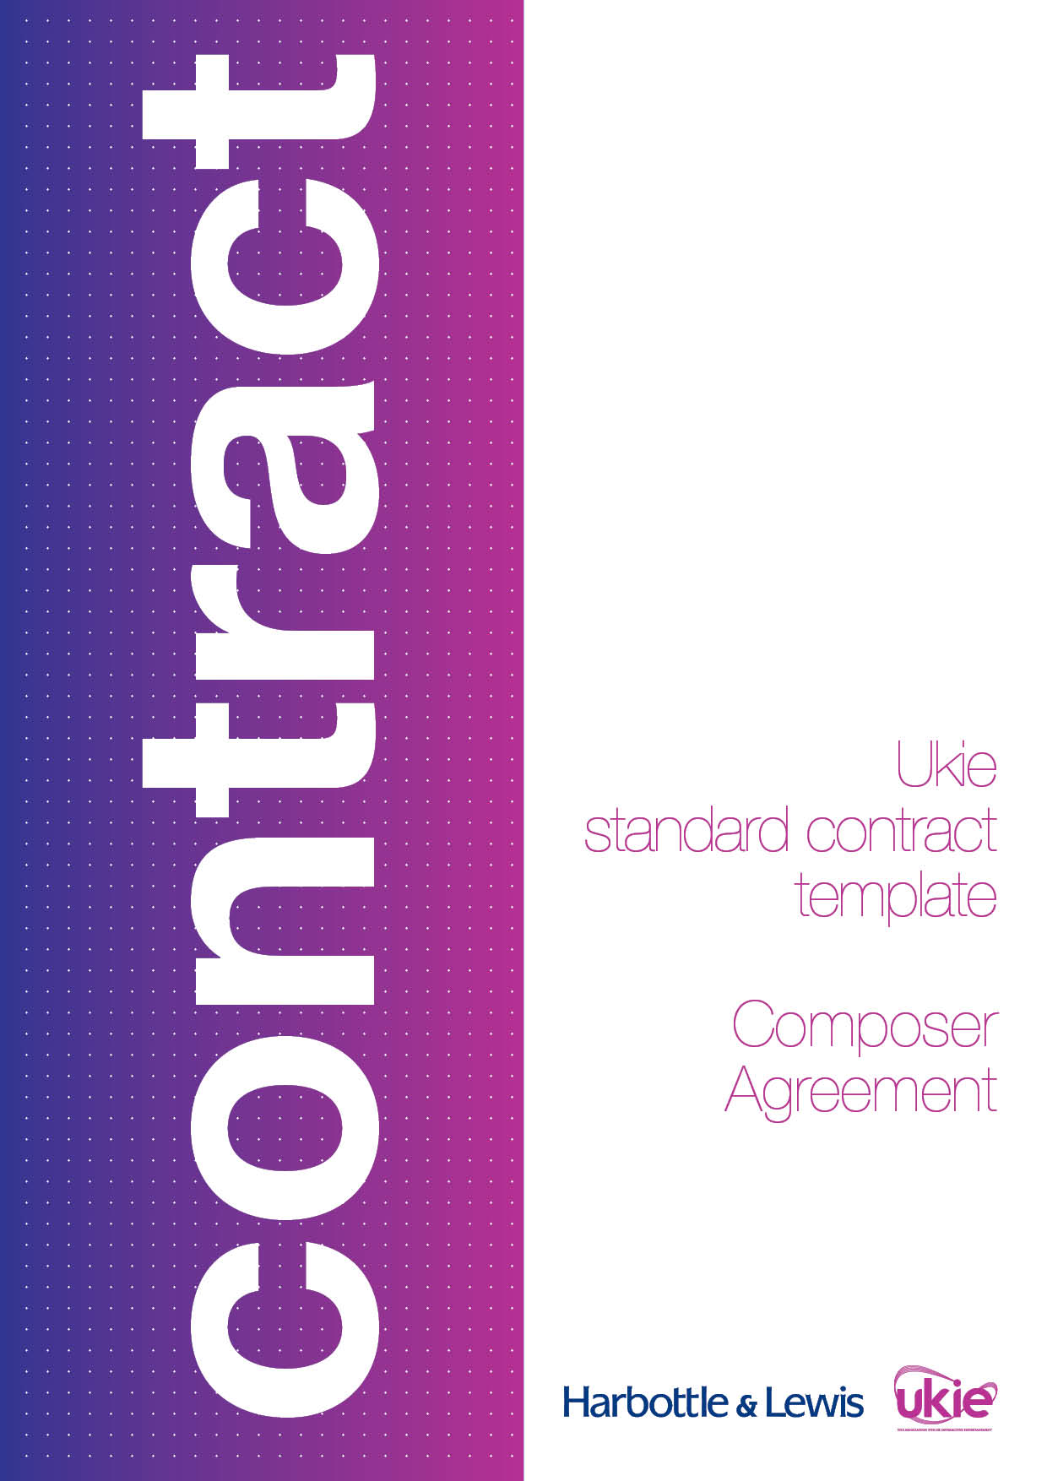

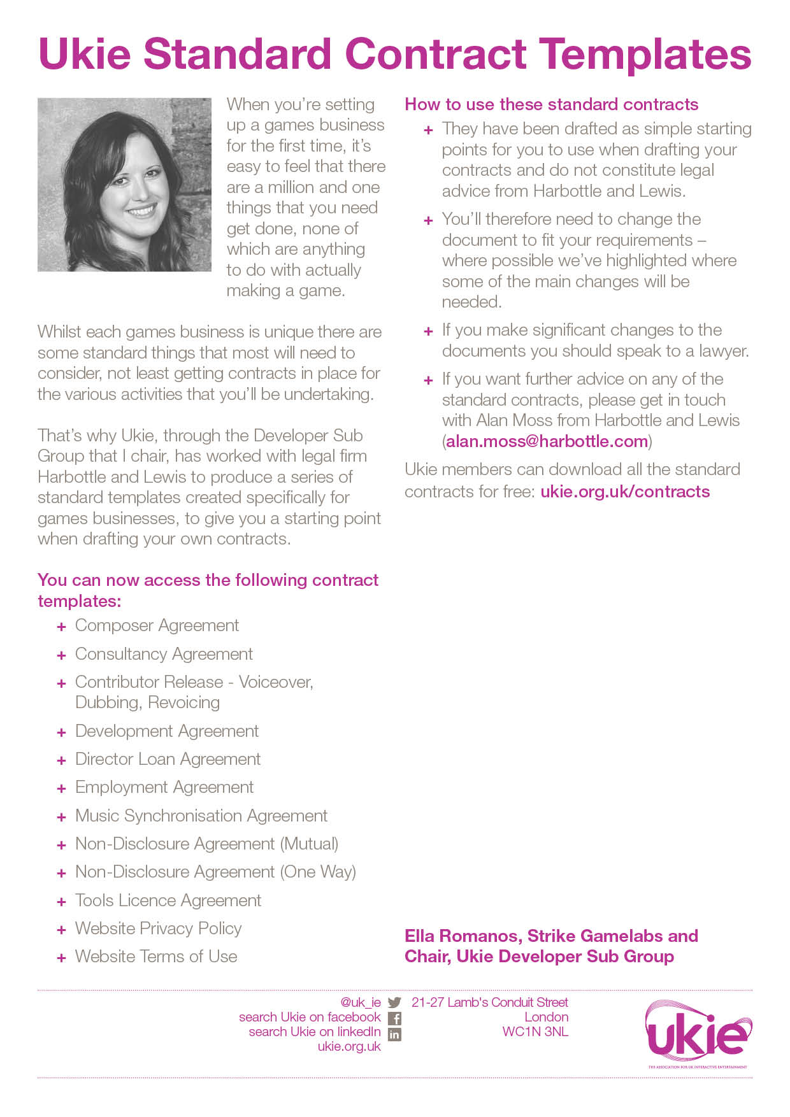

UKIE CONTRACT TEMPLATE
COMPOSER AGREEMENT
IMPORTANT NOTES – PLEASE READ BEFORE USING THIS DOCUMENT
- This document has been prepared by Ukie Associate Member, Harbottle & Lewis. It is a basic composer agreement intended to be used as a starting-point by a party wishing to commission another party to compose new and original music for a video game.
- This document assumes that the relationship between the parties will be an arm’s length work-for-hire arrangement whereby the commissioning party will:
  - commission the commissioned party to develop certain musical compositions and record certain recordings of such musical compositions;
  - own all of the intellectual property rights in the musical compositions and recordings created by the commissioned party from the date on which those deliverables are created;
  - have a right to approve the musical compositions and recordings;
  - pay the commissioned party a fee in instalments; and
  - have no obligation to pay the commissioned party any on-going royalty.
- This document is designed to be fair and balanced and not to place unreasonable obligations on either party. If further protections for either party or a more tailored approach is required, you should seek legal advice.
- This document contains various placeholders in yellow highlighted square brackets that will need to be reviewed and either completed, deleted, accepted or amended before it can be issued.
- This document has been prepared in light of the applicable English law as at April 2016 and will not reflect any subsequent changes to the law after such date.
- This document is intended to be used as a simple starting-point for a first draft of the document and does not constitute legal advice from Harbottle & Lewis LLP. You should seek legal advice if you intend to make any changes to the document. Please contact Chloe Forsyth (chloe.forsyth@harbottle.com) if you wish to discuss any aspect of this document.

Dated 20[]
Composer Agreement

- [INSERT NAME OF DEVELOPER]
- [INSERT NAME OF COMPOSER]

THIS COMPOSER AGREEMENT is made on 20[]
BETWEEN
- [DEVELOPER NAME] a company incorporated under the laws of England and Wales (Company number [INSERT NUMBER]) and having its registered office at [INSERT ADDRESS] which shall include its successors in title, licensees and assigns (Developer); and
- [COMPOSER NAME] of [INSERT ADDRESS] (Composer).
WHEREAS
- Developer is a developer of interactive entertainment games.
- Composer is a professional musician.
- Developer wishes to engage Composer, and Composer wishes to accept such engagement, to compose new and original music and produce audio recordings of such music for a video game which Developer intends (but does not undertake) to develop provisionally entitled “[INSERT TITLE OF VIDEO GAME]” (Game) all in accordance with the terms and conditions of this Composer Agreement (Agreement).
IT IS AGREED as follows:

Composition and Delivery

In consideration of the payment by Developer to Composer of the Fee in accordance with Clause 2.1, Composer hereby undertakes to:

compose the musical composition more fully described in Schedule 1 (Music);

procure the performance and production of the Music for the purposes of making the recordings set out in Schedule 1 (Recordings);

deliver (in a format acceptable to Developer and at Composer’s sole cost and expense) the Music and the Recordings, together with such other musician forms as may be applicable, to Developer by [INSERT DATE] for Developer’s commercial exploitation. For the avoidance of doubt, Developer shall have final approval over the Music and the Recordings; and

perform its services under this Agreement to the best of its ability and in a professional manner.

Fee

Developer shall, subject to its receipt of a valid invoice from Composer, pay to Composer the sum of £[INSERT AMOUNT] (Fee) in the following instalments:
£[INSERT AMOUNT] by no later than [INSERT DATE]; and
£[INSERT AMOUNT] within [INSERT NUMBER] days of the Music and the Recordings being delivered to and approved by Developer.

Composer shall be solely responsible for the payment of all recording costs in connection with the Music and Recordings.

Intellectual Property Rights

Composer hereby unconditionally and irrevocably assigns to Developer and its successors in title by way of a present assignment of all current and future copyright and with full title guarantee, the entire copyright (whether vested, contingent or future) and all rights of action and all other rights of whatsoever nature (including, without limitation, all performers’ property rights) in and to the Recordings and the Music (whether now known or in future created) to which Composer is now or may at any time after the date of this Agreement be entitled by virtue of, or pursuant to, any of the laws in force in any part of the world.

For the avoidance of doubt, the assignment granted by Composer to Developer pursuant to Clause 3.1 above includes, without limitation:

an assignment of all lending and rental rights and cable and satellite retransmission rights in respect of the Music and the Recordings throughout the world for the full period of copyright (or of such other rights as are analogous to copyright) and all revisions, renewals, revivals, extensions and novations thereof and thereafter (so far as possible) in perpetuity;

the right to exploit the Music and Recordings in such manner and through any and all media now existing or invented, developed or made available in the future as Developer shall in its absolute discretion decide;

a so-called “buy-out” without payment of any so-called mechanical licence payments (including, for the avoidance of any doubt, any mechanical royalties); and

the rights to:

re-record and/or re-version the Music and/or the Recordings;

synchronise the Recordings and the Music and any part thereof with any video game (including the Game), application, film, television programme, production, dramatico musical work or any other audio-visual material, in all media;

make adaptations, arrangements, alterations, and translations of the Music and the Recordings;

exploit the Music and the Recordings via commercial release as a record in any format or medium including digital download, either as a single, as part of an album (including as part of a soundtrack album of the Game) or as part of a compilation; and

print, copy and otherwise graphically reproduce the Music.

Composer hereby irrevocably grants to Developer all performer’s consents required pursuant to Part II of the Copyright, Designs and Patents Act 1988 (Act) or pursuant to any other law in any jurisdiction, to enable the exploitation by Developer of the Music and/or the Recordings anywhere in the world.

Composer hereby irrevocably and unconditionally waives in perpetuity all moral rights that Composer may have in and to the Music and the Recordings, whether arising under sections 77 to 85 (inclusive) of the Act or otherwise, and the benefits of any provision of law known as "droit moral" or any similar law in any country of the world and undertakes not to institute, support, maintain or permit any action or lawsuit in any part of the world on the grounds that the Music and/or any of the Recordings or any version or re-recording of the Music and/or any of the Recordings or any derivative right or product in any way constitutes an infringement of any moral rights or "droit moral" of Composer or is in any way a defamation or mutilation of the Music and/or any of the Recordings or contains unauthorised alterations, adaptations or translations or on the grounds that the Music and/or any of the Recordings has been subjected to derogatory treatment.

Composer confirms that the Fee and other consideration contained in this Agreement is:

equitable remuneration for any and all rental and lending rights for the exploitation of Composer’s performance in the Music and/or the Recordings and no further payment shall be due from Developer to Composer; and

inclusive of all royalties or other payments which are due to any individual producer, mixer or remixer of the Recordings or any other person, firm or corporation to whom a royalty or other premium is payable, and all payments due in respect of the Recordings under the agreements and rules of the American Federation of Musicians, AFTRA, or any relevant trust funds or any similar unions.

Developer shall have the right to use the name, likeness and approved biography (such approval not to be unreasonably withheld, conditioned or delayed) of Composer in connection with the use and exploitation of the Music and/or the Recordings.

Credit
Developer shall use its reasonable endeavours to afford Composer the following credit in the credits section of the Game:
“Music by [INSERT NAME].”

Collection Society Payments

Subject to the mechanical buyout contained in Clause 3.2.3 above, nothing in this Agreement shall prevent Composer from receiving income directly from any collection society or agency under collective and other agreements negotiated by recognised collection societies or agencies under the laws of any jurisdiction or any award of the Copyright Tribunal in the UK or any analogous body in the EU, including for the avoidance of any doubt, the right to receive the so-called “writer’s share” and “performer’s share” (if applicable) of public performance income in relation to both the Music and the Recordings respectively (Collection Royalties).

Notwithstanding Clause 5.1, neither Developer nor its licensees or assignees shall be obliged to pay any Collection Royalties to Composer and shall not be obliged to pay to Composer any royalties or other monies from sums received by Developer from the use and/or exploitation of the Music and/or the Recordings hereunder whatsoever.

For the avoidance of any doubt, Developer shall have the right to receive 6/12ths (the so-called “publisher’s share”) of public performance income in relation to the Music.

Representations, Warranties and Undertakings

Each of the parties warrants and undertakes to the other party that it has the right and full power and authority to:

enter into this Agreement;

perform its obligations in accordance with the terms of this Agreement; and

grant the rights and licenses that it is granting to the other party under this Agreement.

Composer hereby represents, warrants and undertakes to Developer that:

no third party has a claim to any of the rights which Composer is granting pursuant to this Agreement and that there is no contract with any person, firm or company to which Composer is a party which will in any way interfere with the exploitation of the Recordings and/or the Music by Developer (or Developer’s licensees or assigns);

the Recordings and the Music are new, original and in the beneficial ownership of Composer, do not infringe the copyright or other rights of any third party, and are not defamatory or obscene;

there is no suit, claim, action or other legal or administrative proceeding now pending or threatened which involves the Music or the Recordings and which might in any way act to impair or deprive Developer of any of the rights herein granted;

Composer has not collected any income in respect of any of the Music and/or the Recordings;

Composer shall not re-record the Music and/or the Recordings for any third party for the period of 5 years from the later of: (i) the date of this Agreement; and (ii) the commercial release of the Game, save that such re-recording restriction period shall in no event be longer than 7 years from the date of this Agreement;

promptly following execution of this Agreement, Composer shall become a member of PRS (if Composer is not already a member of PRS) and Composer shall advise Developer of Composer’s CAE number and Composer agrees that this Agreement shall be regarded as a certificate for the purposes of the PRS's Rule 1(O) authorising the PRS to treat Developer as exploiting the Music for the benefit of the persons interested in them; and

Composer is a “qualifying person” within the meaning of Section 154 of the Act and any modification thereof or substitution therefor.

Indemnification and Default

Composer hereby indemnifies Developer, and shall keep Developer indemnified, from and against all claims, demands, actions, proceedings, costs, damages, losses and expenses (including, but not limited to, any and all legal costs and expenses and VAT) whether suffered or incurred directly or indirectly by Developer or any compensation paid or agreed to be paid by Developer to any third party or arising out of any breach, non-performance or non-observance of any of the covenants, warranties, representations, undertakings and agreements of Composer contained or implied in this Agreement.

Composer agrees that in the event of any default of any of the terms of this Agreement by Developer, Composer’s only remedy shall be an action at law for damages, if any, actually or directly suffered by Composer. In no event shall Composer be entitled to rescind this Agreement, receive injunctive or other equitable relief or enjoin or restrain the distribution, exhibition, advertising or other exploitation of any video games and/or other audio-visual material (including, but not limited to, the Game) which Developer intends to produce or the rights granted hereunder in any jurisdiction throughout the world.

Miscellaneous

Developer shall be entitled to assign or license to any third party or authorise or permit any third party to exercise any or all of the rights of Developer hereunder in the Music and/or Recordings.

If any term of this Agreement is found to be illegal, invalid or unenforceable under any applicable law, such term shall, insofar as it is severable from the remaining terms, be deemed omitted from this Agreement and shall in no way affect the legality, validity or enforceability of the remaining terms provided that if any provision of this Agreement is so found to be invalid or unenforceable but would be valid or enforceable if some part of the provision were deleted, the provision in question shall be amended as may be necessary to make it valid.

This Agreement sets out the entire agreement and supersedes any previous agreement or understanding, whether written or oral, between the parties relating to its subject matter.

This Agreement is binding upon the representatives, executors, administrators and assigns of the parties hereto. The Schedule to this Agreement forms part of this Agreement.

The Contracts (Rights of Third Parties) Act 1999 shall not apply to this Agreement and no person that is not a party to this Agreement shall have any rights under it. This Agreement may be varied, amended, modified, suspended, rescinded or terminated in each case without the consent of any third party.

This Agreement may be executed in any number of counterparts, each of which, when executed and delivered shall constitute a duplicate original, but all the counterparts shall together constitute the one agreement.

This Agreement and any dispute or claim arising out of or in connection with this Agreement or its subject matter (including non-contractual disputes or claims) shall be governed by and construed in accordance with English law and the parties hereby submit to the exclusive jurisdiction of the English courts.
IN WITNESS of which this Agreement has been entered into on the date stated at the beginning of it.
 | [INSERT NAME OF COMPOSER] |  |  | [INSERT NAME OF DEVELOPER]
By: |  |  | By:
Name: |  |  | Name:
Date: |  |  | Title:
 |  |  | Date:

SCHEDULE 1
Music and Recordings
  - The Music:
[INSERT DESCRIPTION AND SPECIFICATION/BRIEF OF THE MUSIC TO BE COMPOSED] (to include, without limitation, background and incidental music, main and end title music, cut scene music, underscore, orchestrations, and musical scores).
  - The Recordings:
Fully mixed master sound recordings of the Music made by Composer including any versions, cutdowns, variations and/or edits thereof.

