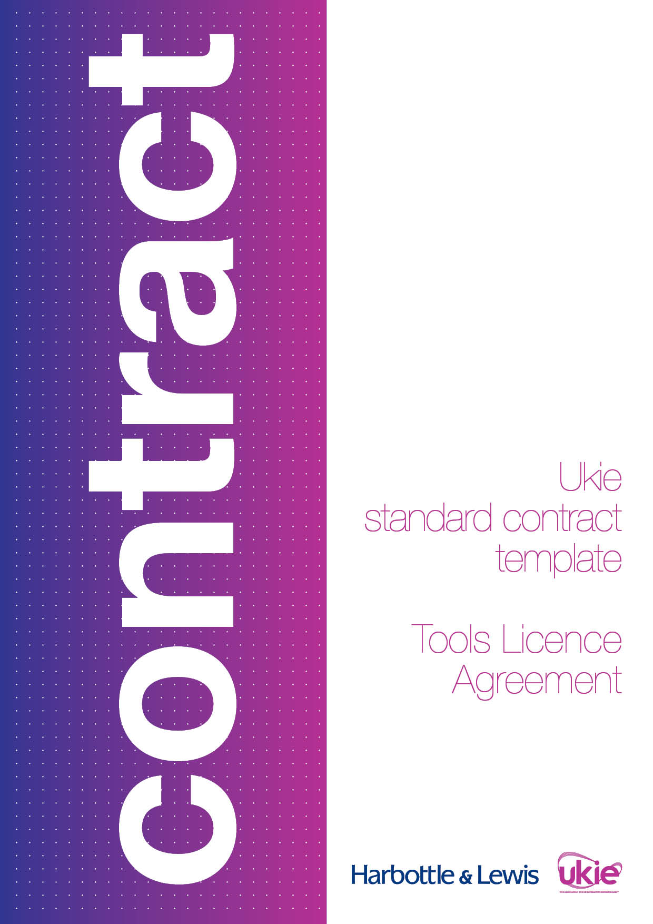

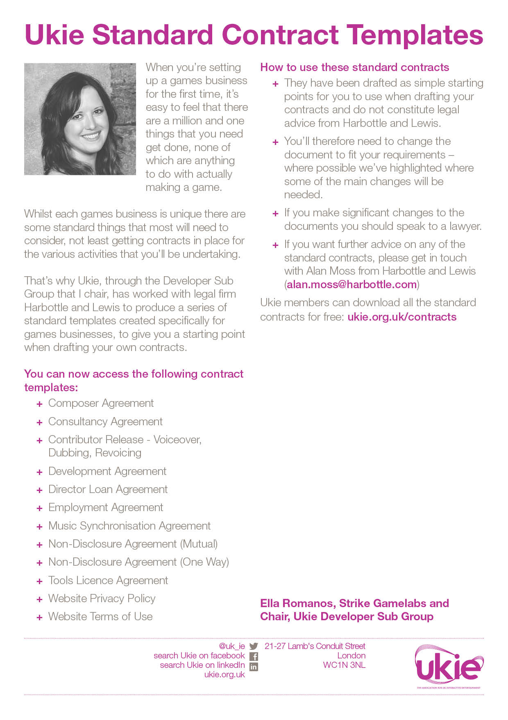

UKIE CONTRACT TEMPLATE
TOOLS LICENCE AGREEMENT
IMPORTANT NOTES – PLEASE READ BEFORE USING THIS DOCUMENT
- This document has been prepared by Ukie Associate Member, Harbottle & Lewis. It is a basic tools licence agreement intended to be used as a starting-point by a party wishing to obtain a licence to use certain tools from another party to in connection with the development of a game.
- This document assumes that the relationship between the parties will be an arm’s length arrangement whereby the party obtaining the licence will pay a one-off upfront fee or a monthly fee to obtain the licence and that no on-going revenue share will be payable to the party licensing the tools. As a result this document does not contain any audit rights for the party licensing the tools.
- The party licensing the tools will continue to own all of the intellectual property rights in the tools being licensed.
- This document is designed to be fair and balanced and not to place unfair or unreasonable obligations on either party. If further protections for either party or a more tailored approach is required, you should seek legal advice.
- This document contains various placeholders in yellow highlighted square brackets that will need to be reviewed and either completed, deleted, accepted or amended before it can be issued.
- This document has been prepared in light of the applicable English law as at April 2016 and will not reflect any subsequent changes to the law after such date.
- This document is intended to be used as a simple starting-point for a first draft of the document and does not constitute legal advice from Harbottle & Lewis LLP. You should seek legal advice if you intend to make any changes to the document. Please contact Alan Moss (alan.moss@harbottle.com) if you wish to discuss any aspect of this document.

Dated 20[]
Tools Licence Agreement

- [INSERT NAME OF LICENSOR]
- [INSERT NAME OF LICENSEE]

THIS TOOLS LICENCE AGREEMENT is made on 20[]
BETWEEN
(1) [INSERT NAME], a company incorporated in England and Wales (company number: [INSERT NUMBER]) of [INSERT ADDRESS] (Licensor); and
(1) [INSERT NAME], a company incorporated in England and Wales (company number: [INSERT NUMBER]) of [INSERT ADDRESS] (Licensee); and
each a Party and together the Parties.
WHEREAS
- Licensor is the owner of the Tools.
- Licensee is a developer of interactive entertainment products.
- The Parties have agreed that Licensor shall, in accordance with the terms and conditions of this Agreement, license the Tools to Licensee in connection with Licensee’s development of the Game.
IT IS AGREED as follows:

Definitions and Interpretations

In this Agreement the following terms shall have the corresponding meanings:
Affiliate | means, with respect to each Party, any company, partnership or other entity which at any time directly or indirectly Controls, is Controlled by or is under common Control with such Party including as a subsidiary, parent or holding company.
Agreement | means this Tools Licence Agreement.
Business Day | means any day other than a Saturday, Sunday or public holiday in the United Kingdom on which banks are generally open for business.
Claim | means any bona fide claim brought by a third party against the Indemnified Party as a direct result of any breach by the Indemnifying Party of any of its representations, warranties, or undertakings under this Agreement.
- Confidential Information | means any information (whether in oral, written, electronic or any other form) relating to: (a) the existence of this Agreement and its terms; (b) the Game; (c) the Tools; and (d) either Party or any Affiliate or any of either Party’s respective businesses, assets, employees, customers or suppliers which either Party may acquire (whether before or after the Effective Date) directly or indirectly from, or in the course of discussions relating to this Agreement, the Game or the Tools, save for any information that was already in the public domain prior to the date of such Party’s acquisition of such information.
- Control | means the power to directly or indirectly control the composition of the board of directors or other managing body of a person, or the direct or indirect possession of more than half of the voting equity share capital of a person. Controlled shall have a correlative meaning.
- Credit | means the credit set out in Schedule 1.
Disclosing Party | has the meaning given to it in Clause 7.1.
Effective Date | means the date on which this Agreement is signed by each of the Parties.
Exploit | means to publish, reproduce, market, promote, advertise, distribute, sell, monetise, licence, publicly perform, display, exhibit, show, play, transmit, broadcast, convey, communicate to the public and otherwise exploit and authorise any third party to do any of the foregoing and the terms Exploitation and Exploiting shall have a correlative meaning.
Fee | means the fee set out in Schedule 1.
Force Majeure | means circumstances beyond a Party’s reasonable control, including acts of God, civil disturbance, riot, acts of war or terrorism, strikes (other than strikes by such Party’s employees or its subcontractor’s employees), lockouts or other industrial disputes.
Format | means the format in which the Tools are to be delivered to Licensee that is specified in Schedule 1.
Game | means the interactive entertainment game that is compatible with the Platforms and is more fully described in Schedule 1.
Indemnified Party | has the meaning given to it in Clause 8.1.
Indemnifying Party | has the meaning given to it in Clause 8.1.
Intellectual Property Rights | means any and all copyright, patents, moral rights, author rights, rental and lending rights, utility models, database rights, rights in designs, trademarks, service marks, goodwill, trade names, domain names, rights in characters, rights in get-up (including in layout, displays, graphics and look and feel), rights in computer software (including in source code, object code, screen displays and user interfaces), topography rights (in all cases whether registered or unregistered or the subject of a pending application and all renewals, reversions, divisions, extensions or revivals of, any such rights), trade secrets, all legal rights protecting the confidentiality of any information or materials and other intellectual property rights, including future rights and all other rights of a similar nature anywhere in the world together with the rights to bring, make, oppose, defend or appeal proceedings, claims or actions, obtain relief and retain any damages recovered in respect of any infringement or other cause of action relating to any of the foregoing rights throughout the world.
Launched | means that the Game has been made available to the public on one or more of the Platforms.
Platforms | means the platforms set out in Schedule 1.
Receiving Party | has the meaning given to it in Clause 7.1.
Taxes | means any value added tax and any other applicable sales, consumption or turnover tax.
Term | has the meaning given to it in Clause 10.1.
Tools | means the development tools set out in Schedule 1.

In this Agreement (except where the context otherwise requires):

any reference to the singular includes the plural and vice versa and any reference to one gender includes all genders;

any reference to a person shall include individuals, bodies corporate, partnerships, unincorporated associations and any other legal or commercial entity or undertaking;

any reference to a Clause or Schedule is to a clause of, or schedule to, this Agreement;

the headings and subheadings used in this Agreement are included for convenience only and shall not be used in construing or interpreting this Agreement;

a reference to any Party shall include, where the context permits, a reference to its legal successors and permitted assignees;

reference in this Agreement to any legislation or to any provision of any legislation shall include any modification, replacement or re-enactment of that legislation for the time being in force and all legislation, orders, regulations, statutory instruments, rules and bye-laws issued under the legislation;

any phrase introduced by the terms include, including, in particular or any similar expression shall be construed as illustrative and without limitation to the words or phrases preceding them;

a reference to in writing or written shall include by email (unless expressly provided otherwise in this Agreement);

all consents, approvals, notices, requests, directions and/or instructions that are required to be given, made or obtained pursuant to this Agreement shall be given or made in writing; and

all consents or approvals that are required to be given or obtained pursuant to this Agreement shall not be, unless otherwise expressly stated, unreasonably withheld, conditioned or delayed.

Grant of Rights and Delivery of Tools

In consideration of Licensee’s payment to Licensor of the Fee in accordance with Clause 3, Licensor hereby grants to Licensee for the duration of the Term, a non-exclusive, worldwide, sub-licensable, royalty-free licence to use, store, reproduce, edit, and create derivative works of, the Tools in connection with the design, development, testing, production and Exploitation of the Game. Any rights not expressly granted to Licensee hereunder are reserved to Licensor.

Licensor shall deliver the Tools to Licensee in the Format within [INSERT NUMBER] days of the Effective Date.

Fee

Licensee shall pay to Licensor the Fee (together with any Taxes payable thereon) [within [INSERT NUMBER] days of Licensee’s receipt of a valid invoice from Licensor for the Fee][on the final Business Day of each calendar month during the Term, subject to Licensee’s receipt of a valid invoice from Licensor for the Fee].

All payments made by Licensee hereunder shall be made by bank transfer (using such payment details as are notified by Licensor to Licensee from time to time).

If Licensee does not pay the Fee to Licensor when properly due in accordance with Clause 3.1, Licensor may:

charge Licensee interest on the overdue amount at the rate of 4% per year above the base rate of the Bank of England from time to time (which interest shall accrue daily until the date of actual payment and shall be compounded quarterly); or

claim interest and statutory compensation from Licensee pursuant to the Late Payment of Commercial Debts (Interest) Act 1998.

Representations, Warranties and Undertakings

Each of the Parties represents, warrants and undertakes to the other Party that:

it is a validly formed company in good standing; and

it has the right and full power and authority to: (a) enter into this Agreement; and (b) perform its obligations in accordance with the terms of this Agreement.

Licensor represents, warrants and undertakes to Licensee that:

it has the right and full power and authority to grant the rights that it is granting to Licensee under this Agreement; and

the Tools do not infringe any third party’s Intellectual Property Rights.

Intellectual Property Rights

The Parties acknowledge and agree that, as between the Parties, all Intellectual Property Rights in the Tools are, and shall at all times continue to be, vested in Licensor (subject to the rights granted to Licensee pursuant to Clause 2). To the extent that Licensee acquires any Intellectual Property Rights in the Tools, Licensee hereby assigns the same to Licensor (by way of present grant and assignment of existing and future rights) for the full period of protection and thereafter (insofar as may be or become possible) in perpetuity.

Credit
If the Game is Launched, Licensee shall ensure that the Credit is included in the Game so as to provide Licensor with attribution for its rights in the Tools.

Confidentiality

Each Party (Receiving Party) acknowledges and agrees that it shall treat as strictly confidential and shall use solely for the purposes contemplated by this Agreement all Confidential Information of the other Party (Disclosing Party).

With the exception of any Confidential Information which:

has come into the public domain through no fault of the Receiving Party;

is required to be disclosed to any authority having the power or authority or other function in relation to tax or other governmental authority in compliance with any applicable legal requirements;

is required to be disclosed by law or by any legal or regulatory authority in connection with any claim, action or other dispute related to this Agreement or otherwise; or

is disclosed by the Disclosing Party to other third parties without restriction on disclosure,

the Receiving Party shall hold and continue to hold in confidence any and all Confidential Information which it receives from the Disclosing Party and shall use at least the same degree of care to prevent the unauthorised use and/or disclosure of such Confidential Information as it uses to protect its own Confidential Information.

Notwithstanding the foregoing, the Receiving Party acknowledges and agrees that it may only disclose any of the Disclosing Party’s Confidential Information to such of its directors, officers, employees, sub-contractors and professional advisers as is strictly necessary for the purposes of this Agreement and shall procure that such persons are aware of and shall comply with the terms of Clauses 7.1 and 7.2 as if they were the Receiving Party and the Receiving Party shall be responsible for and remain fully and primarily liable to the Disclosing Party in respect of any breaches of this Agreement by any such persons.

Indemnity

Each Party (Indemnifying Party) shall defend, indemnify and hold the other Party (Indemnified Party) harmless from all costs, damages, expenses, fees, liabilities and losses (including all judgments, settlements, outside attorneys’ fees) related to any Claim.

With respect to each Claim (if any), the Indemnified Party shall:

promptly notify the Indemnifying Party of such Claim;

permit the Indemnifying Party (through mutually-agreed counsel) to answer and defend such Claim;

make no admission of liability or any other statement in respect of such Claim or attempt to settle such Claim without first obtaining the Indemnifying Party's prior consent; and

provide the Indemnifying Party, at the Indemnifying Party’s cost and expense, such non-confidential information and reasonable assistance, as may be reasonably requested by the Indemnifying Party in connection with the defence of such Claim.

The Indemnified Party may, at its own cost and expense and with separate counsel, monitor or participate in the defence of any Claim. The Indemnifying Party may not settle or publicise any Claim without first obtaining the Indemnified Party’s prior consent.

Limitation of Liability

This Agreement states the full extent of each Party’s liability to the other Party. Save to the extent expressly stated in this Agreement any condition, warranty, guarantee, indemnity, representation or other term relating to each Party’s obligations under this Agreement which might otherwise be implied into or incorporated in this Agreement, whether by statute, custom, practice, common law or otherwise, is hereby excluded to the maximum extent permitted by applicable law.

Subject to Clause 9.3, in no event shall either Party be liable to the other Party in contract, tort (including negligence), pursuant to any statutory duty or otherwise for any: (a) direct or indirect loss of profits, business opportunity, goodwill or anticipated savings; or (b) special, consequential or indirect loss of any kind.

Nothing in this Agreement shall limit or exclude either Party’s liability:

for death or personal injury caused by such Party’s negligence;

for fraud or fraudulent misrepresentation;

under Clause 7 or 8.1; or

for any other liability to the extent that such liability may not be excluded or limited as a matter of applicable law.

Term and Termination

This Agreement shall commence on the Effective Date and shall continue in perpetuity until it is terminated in accordance with this Clause 10 (Term).

Each of the Parties shall be entitled to terminate this Agreement immediately on notice to the other Party in the event that the other Party:

is in material breach of any provision of this Agreement and such breach is incapable of remedy;

fails to remedy any material breach of this Agreement which is capable of remedy within 30 days of its receipt of written notice specifying:

the breach to be remedied; and

the steps required to remedy such breach in reasonably sufficient detail to enable the Party in breach to remedy such breach; or

ceases or threatens to cease carrying on business, calls a meeting of its creditors or makes a proposal for a voluntary arrangement within Part I of the Insolvency Act 1986 or for any other composition or scheme of arrangement with (or assignment for the benefit of) its creditors, is unable to pay its debts within the meaning of section 123 of the Insolvency Act 1986, has a trustee, receiver, administrative receiver or other similar officer appointed in respect of all or any part of its business or assets; has a bankruptcy petition presented against it, convenes a meeting for the purpose of considering a resolution for its winding up (otherwise than for the purpose of a bona fide scheme of solvent amalgamation or reconstruction), is the subject of an administration order, or is subject to any proceeding or circumstance analogous to any of the foregoing in any jurisdiction.

Without prejudice to Clause 3.3, Licensor may terminate this Agreement immediately on notice to Licensee if Licensee fails to pay the Fee to Licensor within [INSERT NUMBER] days of the date on which such payment is due in accordance with Clause 3.1.

Termination of this Agreement for any reason shall be without prejudice to the accrued rights and liabilities of each of the Parties as at the date of such termination.

Promptly following the termination of this Agreement, Licensee shall:

irretrievably delete any copies of the Tools that are in its possession or control; and

notify Licensor of its compliance with Clause 10.5.1.

Any provision of this Agreement which is either expressed to survive termination or by implication ought reasonably to survive termination shall so survive the termination of this Agreement, howsoever caused.

Licensor agrees that in the event of any default of any of the terms of this Agreement by Licensee, Licensor’s only remedy shall be an action at law for damages, if any, actually or directly suffered by Licensor. In no event shall Licensor be entitled to rescind this Agreement, receive injunctive or other equitable relief or enjoin or restrain the distribution, exhibition, advertising or other exploitation of any video games and/or other audio-visual material (including, but not limited to, the Game) which Licensee intends to produce or the rights granted hereunder in any jurisdiction throughout the world.

Force Majeure

Neither Party shall be liable for any delay or failure to perform any of its obligations under this Agreement if that delay or failure is caused by Force Majeure.

If a Party is prevented or delayed in the performance of any of its obligations under this Agreement by Force Majeure, such Party shall be entitled to a reasonable extension of time for the performance of such obligations provided that, if the Force Majeure continues for a period of more than [INSERT NUMBER] days, the Party not subject to the Force Majeure may terminate this Agreement by giving [INSERT NUMBER] days’ prior written notice of such termination to the other Party. Neither Party shall have any liability to the other Party in respect of the termination of this Agreement due to Force Majeure but any rights and liabilities which accrued prior to termination shall subsist.

Miscellaneous

Any notice under this Agreement shall be sent by electronic mail to the relevant addresses as set out below, and any such notice shall be deemed to have been duly served upon receipt of confirmation of delivery:

for Licensor: [INSERT EMAIL ADDRESS] (Attn: [INSERT NAME]); and

for Licensee: [INSERT EMAIL ADDRESS] (Attn: [INSERT NAME]).

Nothing in this Agreement shall be deemed to constitute or imply any partnership, agency, joint venture or fiduciary relationship of any kind between any of the Parties or, save as expressly set out in this Agreement, shall authorise either Party to act as agent for the other, or to act in the name, or on behalf, of or otherwise make any commitments on the other Party’s behalf.

Each Party shall pay its own costs incurred in connection with this Agreement.

This Agreement sets out the entire agreement and supersedes any previous agreement or understanding, whether written or oral, between the parties relating to its subject matter.

If any term of this Agreement is found to be illegal, invalid or unenforceable under any applicable law, such term shall, insofar as it is severable from the remaining terms, be deemed omitted from this Agreement and shall in no way affect the legality, validity or enforceability of the remaining terms provided that if any provision of this Agreement is so found to be invalid or unenforceable but would be valid or enforceable if some part of the provision were deleted, the provision in question shall be amended as may be necessary to make it valid.

No modification, amendment or variation to this Agreement shall be valid unless it is in writing and signed in manuscript by or on behalf of each of the Parties to this Agreement.

A failure to exercise or a delay in exercising any right, remedy or power provided under this Agreement or by law shall not constitute a waiver of such right, remedy or power or a waiver of any other right, remedy or power. No single or partial exercise of any right, remedy or power shall prevent any further exercise of it or the exercise of any other right, remedy or power.

Neither Party shall assign or purport to assign all or any part of the benefit of or all or any of its rights under this Agreement without the prior consent of the other Party provided that each Party may assign any or all of its rights under this Agreement to any:

of its Affiliates; or

third party which: (a) succeeds such Party by operation of law; or (b) purchases or otherwise acquires substantially all of such Party’s assets.

The Contracts (Rights of Third Parties) Act 1999 shall not apply to this Agreement and no person that is not a party to this Agreement shall have any rights under it. This Agreement may be varied, amended, modified, suspended, rescinded or terminated in each case without the consent of any third party.

This Agreement be signed in any number of counterparts or by fax or other electronic means to accurately send images, each of which, when signed, shall be an original and all of which together evidence the same Agreement.

This Agreement and any dispute arising out of or in connection with it (including any non-contractual claims) shall be governed by and construed in accordance with English law and both Parties agree to exclusive jurisdiction of the English courts and waive any argument that this is an inconvenient forum.
IN WITNESS of which this Agreement has been entered into as of the Effective Date.
 | [INSERT NAME OF LICENSOR] |  |  | [INSERT NAME OF LICENSEE]
By: |  |  | By:
Name: |  |  | Name:
Title: |  |  | Title:
Date: |  |  | Date:

Schedule 1
Game: | [Set out the name and a description of the game that will incorporate the development tools]
Platforms: | [Set out the platforms on which the game will be released]
Tools: | [Set out details of all the development tools that are to be licensed to Licensee]
Format: | [Set out details of format in which the development tools are to be delivered to Licensee]
Credit: | [Set out the credit that must be included in the game]
Fee: | £[INSERT AMOUNT]

